Chapter 1 - About Grandpa and my ancestry
Grandpa’s birthday falls on 12th of June, and he turned 83 in 2012. He was born in 1928. Amma tells her age to be 7-8 years younger than him. Her UIDAI card has the year 1936.

Level 1:
Lalu None Rai (grandpa tells "all that he used to do was sit at the temple, next to the entrance to the main central hall")

Level 2: Ganwar Lal

Level 3:
3.1. Ugrasen Jain, he was the eldest of the three brothers. He had done BA, LLB.

3.2. Phool Chand Jain
Phool Chand Jain was grandpa’s father. He passed away in 1978.
He would later have two sons. Digamber Prasad Jain (my grand father and elder of the two brothers) and Hem Chand Jain (my grand uncle and the younger brother).

3.3. Maksoodan Lal. He was the youngest of the three.

HOMETOWN: Gohana (near Sonepat), Haryana
Maksoodan Lal’s Son: Vinod Jain
Hem Chand Jain sold his part of the property (backyard and some neighboring portions) from the Haveli in Gohana to Vinod Jain.
Amma tells: Phool Chand Jain had his sons (Digamber Prasad Jain and Hem Chand Jain) for their expectations from him as in "bol tu kya lega?". Grandfather said he does not want anything. Hem Chand Jain asked for backyard from the property.

Level 4:
4.1. Digamber Prasad Jain. My grandfather was the elder of the two brothers. He was elder by an year.
Studied BA, LLB (Civil), and later went to Tis Hazari Court, Delhi.

4.2. Hem Chand Jain [Lives in Tri Nagar, Delhi, India]

Phool Chand Jain had set up the house in Tri Nagar around the time of 1958, and grandpa and Hem Chand Jain settled here in Tri Nagar around then.

About Gohana

Gohana is a sub-division/tehsil, a town and a municipal committee in Sonipat district in the Indian state of Haryana.
Geography: Gohana is located at 29.13°N 76.7°E. It has an average elevation of 225 meters (738 feet).
Demographics: Gohana town is situated in Sonipat district of Haryana. It is a main sub-division of more than 300,000 populations now in year 2011, has its own municipality and a constituency for Haryana Vidhan Sabha. Villages in Gohana (Subdivision) are around 86.It is located in west from District Sonipat. From the district, its distance is 40 km. Earlier it was part of Rohtak district. [Ref: May 20, 2021 (Wikipedia)]

~ ~ ~

Gohana is a city and a municipal council, near Sonipat city in the Sonipat district of the Indian state of Haryana.
Gohana city is situated in the Sonipat district of Haryana. It is the main subdivision with a population of more than 300,000 (as of 2011). It has its own municipality and a constituency for Haryana Vidhan Sabha. There are around 86 Villages in Gohana. [Ref: Wikipedia, 2022-Oct-4]

Level 5:

Babaji’s mother was a native of Sonepat, Haryana. Babaji’s parents had lived in Gohana, Haryana.
Grandma’s family lived in BADSHAHPUR (near Gurgaon), Haryana. Amma was ten when her family moved to Delhi in around 1947. Amma tells of the Hindu-Muslim riots happening around the city during that time of country’s independence.
After marriage, amma moved to Gohana where babaji’s family lived. Babaji was practicing in Delhi, and used to visit Gohana to see his family often. Four of six children had their birth in Gohana, only Rekha buaji and Manju buaji were born in Delhi.

Jainism and its influence on my grandparents

Amma has always been very religious and holds very strong belief in God and Jainism. She went to a Jain school as a child, and she didn’t do schooling after fifth standard. At the Jain school, she was taught all the prayers, the rituals, the beliefs, rules and practices of Jainism. Her school wasn’t a separate body, but in conjunction with the temple.
She has a small metallic tray that was distributed in her school on the occasion of first republic day of our country, Jan-26-1951.

Babaji’s family had always held positions in the management of the temple. Phool Chand Jain was the president of the temple management body, and his cousin brother, Padam Jain had some prominent position in the management. Babaji’s distant-cousin and Padam Jain’s son became temple’s cashier later.

Around in 1950, when babaji got down with serious illness, which he recollects as TB, Phool Chand Jain went to Ayodhya to bring and set up the orange-marble idol of Lord Mahavira in the temple. The central main idol is about 900 years old, from the times of TUGHLAQ'S rule in Delhi, 1200 AD. There is a saying, ‘the older the temple, the more are the powers in it’. The idol that Phool Chand Jain brought is kept in the left section of the temple, and at about three feet, the idol is the largest idol present there, the main idol is about two feet high. The main hall in the temple is itself not very large, with the three sections covering an area of about 8-by-4 meters-squared.

Manu Apartments

Mavilla apartments put up silver-jubilee banner, society was 25 years old (1987-2012).
As amma tells, the cost of the flat in Manu Apartments had come up to be 4 Lacs (0.4 million INR). That should be the cost to investor buyers.

30-40 years ago: babaji had registered in the court with a person for the land for the lawyers for some R200 and since then they had be giving the installments as were required until the flats were ready. He got lucky in the draw and got the first flat, the flat number one.

The flat now stood at 15 million INR as the base value for the owners. Otherwise, its present let-out sale price for a buyer will be over 30 million. That is 90 times the investment value for the flat 25 years ago.

Family Tree (Incomplete)

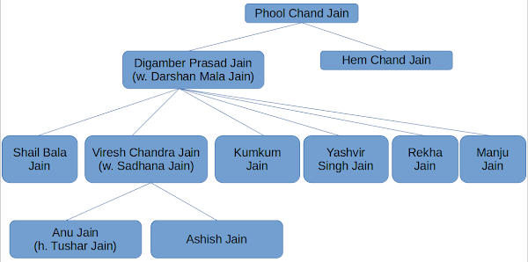

Dates of birth, marriages and deaths of other relations.

Name: Digamber Prasad Jain
DOB: 1929-Jun-12
Married to: Darshan Mala Jain
Date of marriage: 1955-Feb-7
Passed Away: 2021-Feb-19
Relation: Grandfather

Name: Darshan Mala Jain
DOB: 1936 or 1937. It could be Oct or Nov on the day of Hoi festival.
Married to: Digamber Prasad Jain
Date of marriage: 1955-Feb-7
Note: Maina mausiji was born on 20-nov as per what she gave in the government-papers in Gujarat randomly.
Relation: Grandmother

Name: Shail Bala Jain
DOB: 1956-Sep-5
Nickname: Maalo or Maalu
Note: Shail Bala died at the age of 6/7, in the first standard. She succumbed to the high fever of about 107 Fahrenheit; it had reached her brains. I never knew her name until I was 20, I had heard of her when I was third and her story had found a place in my head right around that time, but without any description of anything, no facts, nothing at all, and just a story.

Name: Viresh Chandra Jain
DOB: 1958-Nov-27 (0400)
Married to: Sadhana Jain
Nickname: Babbu / Sheru / Sheru Mohammed
Passed Away: 2012-Apr-24
Relation: Father

Name: Sadhana Jain
DOB: 1965-Sep-05
Married to: Viresh Chandra Jain
Relation: Mother

Name: Kumkum Jain
DOB: 1960-Oct-26
Married to: Anil Kumar Jain
Nickname: Baby / Kammo
Relation: Badi Bua Ji

Name: Yashvir Singh Jain
DOB: 1962-May-21
Married to: Seema Jain
Date of marriage: 1991-Dec-7
Nickname: Neetu / Notli
Relation: Chacha Ji (Uncle)

Name: Seema Jain
DOB: Sep-24
Married to: Yashvir Singh Jain
Date of marriage: 1991-Dec-7
Relation: Chachi Ji

Name: Rekha Jain
DOB: 1964-Mar-21
Married to: Rajiv Jain
Date of marriage: Feb-17
Nickname: Toti
Relation: Bua Ji

Name: Manju Jain
DOB: 1966-Nov-03
Married to: Salil Jain
Date of marriage: 1997-Nov-22
Relation: Bua Ji

Name: Ankur Jain
DOB: 1989-Sep-19
Relation: Cousin (Son of Kumkum Jain)

Name: Anu Jain
DOB: 1990-Sep-06
Nickname: Bulli
Married to: Tushar Jain

Name: Ashish Jain
DOB: 1991-Dec-18
Nickname: Bhala, Bhalai, Bhalu
Relation: Myself

Name: Prashant Jain
DOB: 1992-Jan-20
Nickname: Munna

Name: Shruti Jain
DOB: 1993-Sep-03

Name: Rashmi Jain
DOB: 1993-Apr-08

Name: Srishti Jain
DOB: 1994-Oct-22
Nickname: Gudiya / Gulgul

Name: Smita Jain
DOB: 1995-Apr-08
Nickname: Lily

Name: Sameer Jain
DOB: 1998-Jan-08

Name: Prachi Jain
DOB: 1999-Apr-29
Nickname: Puchchi / Poochi

Name: Anushka Jain
DOB: 2007-Jan-30
Nickname: Chhutki, Gudiya

Grand Uncle (Hem Chand Jain) still stays in Tri Nagar (House Number 1142, Street 75) and is now a great grand father of the daughter of Mayank.

Chapter 2 - My schooling and my grandparents' YOBs

Hospital I Was Born In
St. Stephens Hospital, New Delhi
(St Stephens Hospital, Tis-Hazari, Nawab Ganj, New Delhi, Delhi, India, ststephenshospital.org)
Wednesday, 18 December, 1991, 1100 hours.

Schools and Corresponding Years

XII | 2008-09 | Ahlcon Public School
XI | 2007-08 | Ahlcon Public School
X | 2006-07 | Ahlcon Public School
IX | 2005-06 | Ahlcon Public School
VIII | 2004-05 | Ahlcon Public School
VII | 2003-04 | Ahlcon Public School
VI | 2002-03 | Ahlcon Public School
V | 2001-02 | Ahlcon Public School
IV | 2000-01 | Maharaja Agrasen Public School
III | 1999-2K | Maharaja Agrasen Public School
II | 1998-99 | Maharaja Agrasen Public School
I | 1997-98 | Maharaja Agrasen Public School
Kindergrtn | 1996-97 | Maharaja Agrasen Public School
During Pre-school years: Municipal Corp. Gov. Primary School (*)
Blue Bells Primary School (for very short duration, Anu also went there)

College

2009-2013: Indraprastha University (Northern India Engineering College (Later aka Akhilesh Das Gupta Institute of Technology and Management))

2017-2018: Birla Institute of Techonology and Science, Pilani

2019 Onwards: University of Hard Knocks, College of 'survival8'

YOBs of my grandparents

1. UIDAI - Grandma

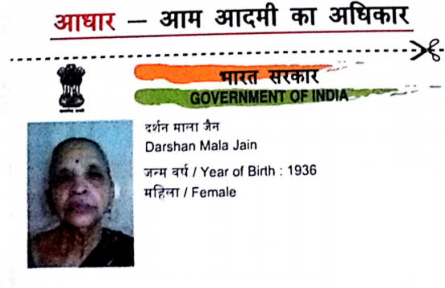

2. UIDAI - Grandpa
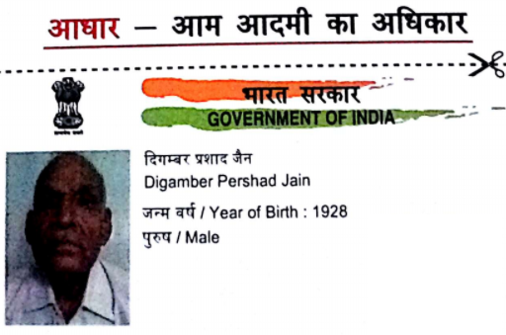

3. Voter ID - Grandma
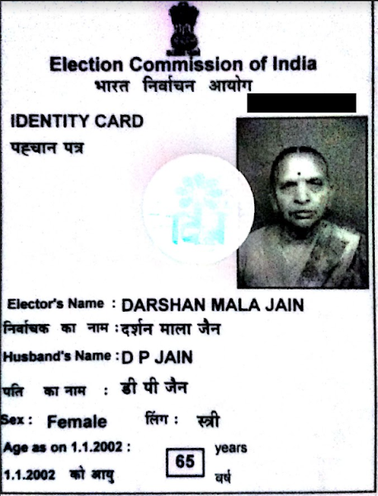

4. Voter ID - Grandpa
